COMPLETE RAG
RETRIEVAL EVALUATION GUIDE
Chunk-level metrics • Mathematical formulas • Worked examples • Visuals • Quick reference

Scope A comprehensive guide to evaluating chunks retrieved from a document collection or vector database such as Qdrant. It is written for the current StudyRag stage, where retrieval is evaluated without an LLM answer-generation stage.

Context: Docling parsing/chunking • BAAI/bge-small-en-v1.5 • Qdrant • dense, sparse and hybrid retrieval

1. What retrieval evaluation measures
A retrieval pipeline accepts a user query, embeds or tokenizes it, searches an index, and returns ranked chunks. Evaluation compares those retrieved chunks with human-annotated relevant evidence.
- Retrieval effectiveness: whether the correct evidence is found, how much relevant evidence is found, and how well it is ranked.
- Retrieval diagnostics: whether results are duplicated, diverse, and drawn from useful sources.
- Retrieval efficiency: latency, throughput, memory, index size, and indexing speed.
Because StudyRag currently ends at retrieved chunks, prioritize Information Retrieval (IR) metrics. Do not treat LLM answer-quality metrics as current retrieval metrics.

2. Shared example and terminology
Example query: “What minimum megohmmeter reading does Toshiba recommend before applying power to a stored motor?”
Suppose the relevant evidence states: “The insulation resistance should be at least 10 megohms before applying power.”
Rank | Retrieved chunk | Relevant?
1 | Motor storage recommendations | No
2 | Insulation resistance testing | Yes
3 | Motor bearing lubrication | No
4 | Electrical safety procedures | Yes
5 | Motor installation instructions | No

This example has two relevant retrieved chunks among five; the first relevant result is at rank 2. Some later examples explicitly assume a different ground-truth count.
K means the number of results considered (for example, top 5 or top 10). A relevant chunk is one marked relevant by the human-annotated ground truth. Rank 1 is the highest-ranked result.

3. Core retrieval effectiveness metrics

3.1 Hit Rate@K / Hit@K
Question: Did the retriever find at least one relevant chunk in the top K?
Hit@K(query) = 1 if at least one relevant chunk appears in top K; otherwise 0
Hit Rate@K = number of queries with a hit / total number of queries
Example: among three queries, Q1 and Q2 have a relevant result in top 5 and Q3 has none. Hit Rate@5 = 2/3 = 0.6667 (66.67%).
Interpretation: 66.67% of queries found at least one relevant chunk. The remaining 33.33% were misses.
Limitation: Hit Rate does not care where the relevant result appears or how many relevant chunks are found. A hit at rank 1 and a hit at rank 5 both count as 1.

3.2 Recall@K
Question: What fraction of all known relevant chunks for a query were retrieved in the top K?
Recall@K = relevant chunks retrieved in top K / total relevant chunks for that query
Example: if the ground truth contains three relevant chunks and top 5 contains two, Recall@5 = 2/3 = 0.6667.
Interpretation: about 66.67% of annotated relevant evidence was retrieved; about 33.33% was missed.
Why it matters: a troubleshooting question may need a fault description, possible causes, and corrective actions. Finding only one section can leave evidence incomplete.
Ground-truth dependency Recall is only trustworthy if all relevant evidence chunks are annotated. If the dataset records one relevant chunk while several exist, measured recall can be misleading.

3.3 Precision@K
Question: Of the top K retrieved chunks, what fraction are relevant?
Precision@K = relevant chunks in top K / K
Example: six relevant chunks among ten results gives Precision@10 = 6/10 = 0.60.
High precision means fewer irrelevant results. Low precision means more noise. When generation is added later, irrelevant chunks may consume context-window space and distract the generator.

3.4 F1@K
Question: What is the harmonic-mean balance between precision and recall?
F1@K = 2 × (Precision@K × Recall@K) / (Precision@K + Recall@K)
Example: Precision = 0.60 and Recall = 0.80 gives F1 = 2 × (0.60 × 0.80)/(0.60 + 0.80) = 0.6857.
Use F1 as a compact summary, not as a replacement for reporting precision and recall separately. The same F1 can hide different precision/recall trade-offs.

3.5 Mean Reciprocal Rank (MRR@K)
Question: How high in the ranking does the first relevant chunk appear?
RR(query) = 1 / rank of the first relevant result
MRR@K = mean of per-query reciprocal ranks across all queries
First relevant rank | Reciprocal rank
1 | 1.000
2 | 0.500
3 | 0.333
4 | 0.250
5 | 0.200
10 | 0.100
Not found in K | 0

Example: four queries have first relevant ranks 1, 2, 4, and not found. MRR = (1 + 0.5 + 0.25 + 0)/4 = 0.4375.
MRR only considers the first relevant result. It rewards a useful chunk near the top but ignores other relevant chunks further down.

MRR visual: reciprocal rank falls as the first relevant chunk appears lower
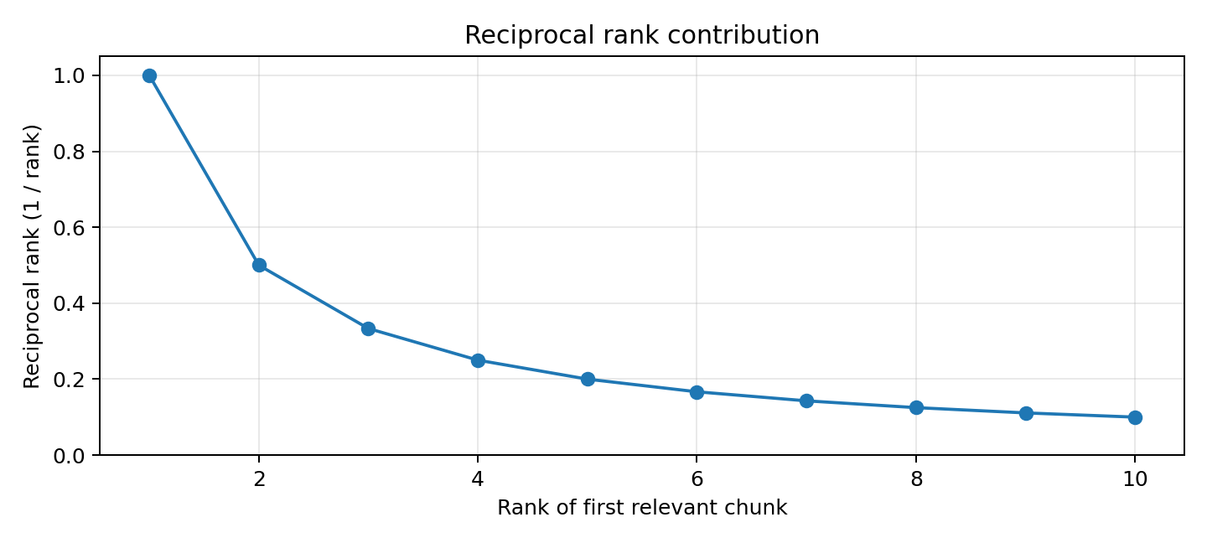
The reciprocal-rank contribution is 1/rank. MRR averages these values over queries.

3.6 Normalized Discounted Cumulative Gain (NDCG@K)
Question: How good is the overall ordering of retrieved results, accounting for relevance at every position?
NDCG can use binary relevance (0/1) or graded relevance, such as 0 = irrelevant, 1 = partially relevant, 2 = relevant, and 3 = highly relevant.
DCG@K = Σ(i=1 to K) [(2^rel_i − 1) / log2(i + 1)]
rel_i is the relevance grade at rank i. The gain term gives greater weight to highly relevant chunks; the logarithmic discount reduces the contribution of chunks at lower ranks.
Relevance grade | Gain (2^rel − 1)
0 | 0
1 | 1
2 | 3
3 | 7

Ideal DCG (IDCG) is the DCG for the same relevance grades sorted in the ideal order.
NDCG@K = DCG@K / IDCG@K
Worked example: ideal grades [3, 2, 1, 0, 0] give IDCG@5 = 7/log2(2) + 3/log2(3) + 1/log2(4) = 7 + 1.893 + 0.5 = 9.393.
NDCG = 1 means ideal ordering; 0 means no gain from relevant results. NDCG measures ranking quality relative to the best possible ranking.

NDCG visual: lower positions receive less weight
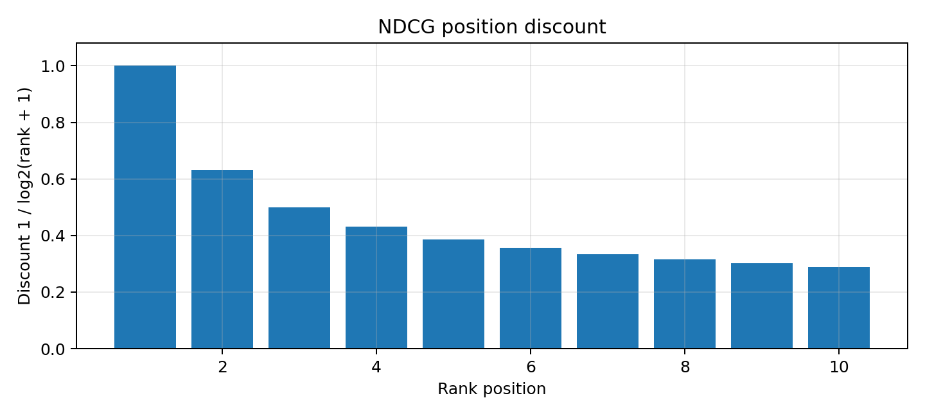
The same relevance grade contributes less at rank 5 than at rank 1 because of the position discount.

3.7 Mean Average Precision (MAP@K)
Question: Across queries, how consistently does the retriever rank multiple relevant chunks near the top?
AP@K = [Σ(i=1 to K) (Precision@i × rel_i)] / total relevant chunks for that query
rel_i is 1 if the result at rank i is relevant and 0 otherwise. Average Precision averages the precision values at ranks where relevant results occur. MAP is the mean AP across queries.
Rank | Relevant? | Precision at rank
1 | Yes | 1/1 = 1.00
2 | No | Not included
3 | Yes | 2/3 = 0.667
4 | Yes | 3/4 = 0.750
5 | No | Not included

AP@5 = (1.00 + 0.667 + 0.750) / 3 = 0.806
The denominator is the total number of relevant chunks for the query (three in this example). MAP is useful when a query has multiple relevant evidence chunks.

3.8 R-Precision
Question: What is precision when retrieving exactly R results, where R is the number of relevant chunks for that query?
R-Precision = relevant chunks in top R / R
Example: if a query has four relevant chunks and three of the top four results are relevant, R-Precision = 3/4 = 0.75. It adapts the cutoff to each query's number of relevant chunks.

3.9 Recall@K curve
Measure recall at multiple cutoffs, such as K = 1, 3, 5, 10, 20, and 50, rather than only at K=10.
Cutoff | Illustrative recall
Recall@1 | 0.35
Recall@3 | 0.48
Recall@5 | 0.58
Recall@10 | 0.67
Recall@20 | 0.81
Recall@50 | 0.93

Illustrative Recall@K curve
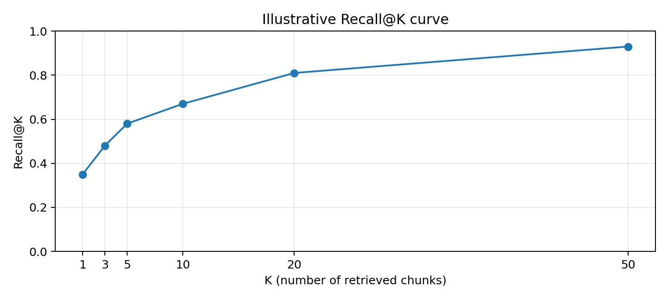
These values are examples, not StudyRag measurements. A rise from Recall@10 to Recall@20 suggests some relevant evidence is ranked below position 10.
This curve helps distinguish a coverage failure (relevant evidence never retrieved) from a cutoff/ranking issue (relevant evidence appears lower down).

4. Compare the core metrics
Metric | What it asks | Ranking-sensitive?
Hit Rate | Did I find at least one relevant chunk? | No
Precision | How many retrieved chunks are relevant? | No (at fixed K)
Recall | How many known relevant chunks did I retrieve? | No (at fixed K)
F1 | What is the precision/recall balance? | No (at fixed K)
MRR | Where is the first relevant chunk? | Yes
MAP | How well are multiple relevant chunks ranked? | Yes
NDCG | How good is the full ranked list, including graded relevance? | Yes
R-Precision | How precise are the top R results? | No (at fixed R)

Memory aid: Hit Rate = did I find anything? Recall = how much useful evidence did I find? Precision = how clean are the results? MRR = how soon did I find the first useful result? NDCG = did I rank all useful results well? MAP = did I rank multiple relevant results early?

5. Retrieval diagnostics: duplicates, diversity and source coverage

5.1 Duplicate Retrieval Rate@K
Question: How many returned chunks repeat the same content or substantially duplicate one another?
Duplicate Rate@K = duplicate retrieved chunks / total retrieved chunks
Example: two duplicate chunks among five results gives 2/5 = 0.40. Track exact duplicates separately from near-duplicates.
- Possible causes: overlapping chunks, repeated source content, duplicate ingestion, or highly similar sections.
- For Docling chunking, inspect whether overlap or repeated document structures create redundant results.

5.2 Diversity@K / Intra-List Diversity (ILD)
Question: Do retrieved chunks cover different relevant sections or repeat one narrow aspect?
ILD@K = [Σ(i ≠ j) (1 − Sim(d_i,d_j))] / [K(K − 1)]
Sim(d_i,d_j) is pairwise similarity between retrieved chunks. Higher ILD indicates more dissimilar/diverse results. Other diagnostics include unique sources@K, unique sections@K, and unique topics@K.
Caution Higher diversity is not automatically better. For a precise specification, several chunks from the same manual section may be ideal. Interpret diversity alongside relevance.

5.3 Source Coverage@K
Question: How many distinct source documents contribute to the top K?
Example: top five chunks come from Toshiba, Toshiba, Baldor, Toshiba, and Siemens manuals. There are three unique sources. This can reveal source concentration, but more sources do not automatically mean better relevance.

6. Retrieval-system performance metrics

6.1 Retrieval latency
Question: How long does it take to retrieve results?
Example breakdown: query embedding 15 ms + Qdrant search 25 ms + result processing 5 ms = 45 ms total.
Statistic | Meaning
Average | Mean request duration; can hide slow outliers.
P50 | Median; half of requests finish at or below this value.
P95 | 95% of requests finish at or below this value.
P99 | 99% of requests finish at or below this value.

P95 and P99 are often more useful than average latency for production because they reveal slow-tail behaviour.

6.2 Throughput / QPS
QPS = total queries processed / elapsed time in seconds
Example: 1,000 queries in 20 seconds = 50 QPS. Record concurrency, hardware, batch size, and whether query-embedding time is included.

6.3 Index size and memory
Monitor vector storage size, number of indexed vectors, RAM consumption, disk usage, and memory use during indexing and search. Strong NDCG is not sufficient if the index is too costly to operate.

6.4 Indexing throughput
Indexing throughput = number of chunks indexed / time taken
Example: 10,000 chunks in 100 seconds = 100 chunks/second. Measure parsing, chunking, embedding generation, and Qdrant upserting separately to identify bottlenecks.

7. Embedding and similarity-search diagnostics

7.1 Similarity score distribution
Inspect similarity scores returned by Qdrant. Example scores might be 0.87, 0.82, 0.79, 0.51, and 0.49.
Important A similarity score of 0.87 is not an 87% probability that a chunk is relevant. Similarity is a model/index score, not a calibrated probability.

Compare score distributions for relevant and irrelevant chunks. Examine overlap, score gaps, query categories, and source documents.

7.2 Threshold-based precision and recall
If results are filtered by a similarity threshold, measure precision and recall at several thresholds.
Illustrative threshold | Precision | Recall
0.50 | 0.55 | 0.90
0.60 | 0.67 | 0.82
0.70 | 0.80 | 0.65
0.80 | 0.91 | 0.40

Illustrative similarity threshold trade-off
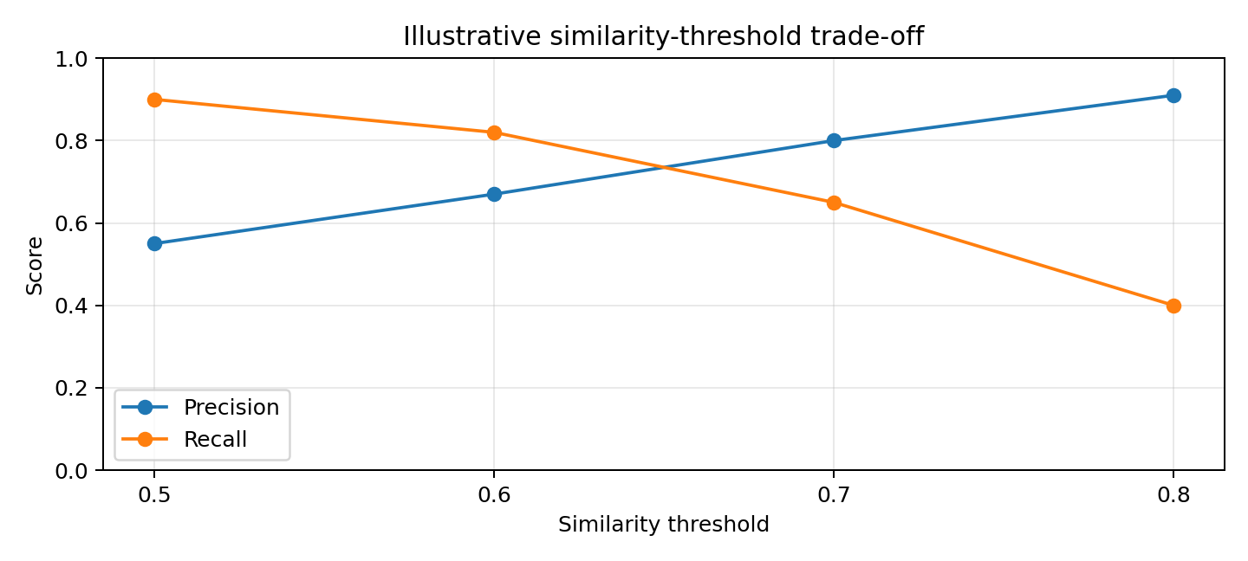
Example only: a stricter threshold may improve precision while reducing recall. Actual results depend on the model, metric, and corpus.
Thresholds do not necessarily transfer between embedding models, distance metrics, or datasets.

7.3 Exact identifiers and numeric specifications
Industrial manuals contain exact fault codes, model numbers, part numbers, and numeric specifications. Dense retrieval can struggle with exact strings and token-level matching.
- Create a fault-code query slice (for example, F001).
- Create a model/part-number slice (for example, bearing model 6205).
- Create a numeric-specification slice (for example, torque for bolt M12 or minimum insulation resistance).
Track exact identifier retrieval accuracy, numeric-specification retrieval accuracy, and keyword/lexical retrieval accuracy. BM25 or another lexical approach can complement dense embeddings.

8. Interpreting the reported StudyRag results
Metric | Reported score | Meaning
Hit Rate | 0.6667 | About 66.67% of queries found at least one relevant chunk.
Recall | 0.6667 | About 66.67% of annotated relevant chunks were retrieved, subject to the implementation's averaging.
MRR | 0.5370 | Mean reciprocal rank of the first relevant result is 0.537.
NDCG | 0.5701 | Ranking quality is 57% of ideal DCG under the selected relevance labels and gain formula.

- Hit Rate: about one-third of queries have no relevant result in the evaluated top K. Inspect failed queries.
- Recall: some annotated evidence is missing. Check K, ground-truth completeness, parsing, chunk boundaries, vocabulary mismatch, and retrieval method.
- MRR: the first relevant result is not consistently near the top. Investigate ranking and reranking.
- NDCG: overall ordering can improve. Verify binary versus graded relevance and whether highly relevant chunks rank first.
The four aggregate values do not identify the root cause. Generate a per-query report with expected evidence, retrieved IDs, relevance at each rank, scores, and source metadata.

9. Recommended retrieval-improvement workflow

Possible next-stage StudyRag retrieval architecture
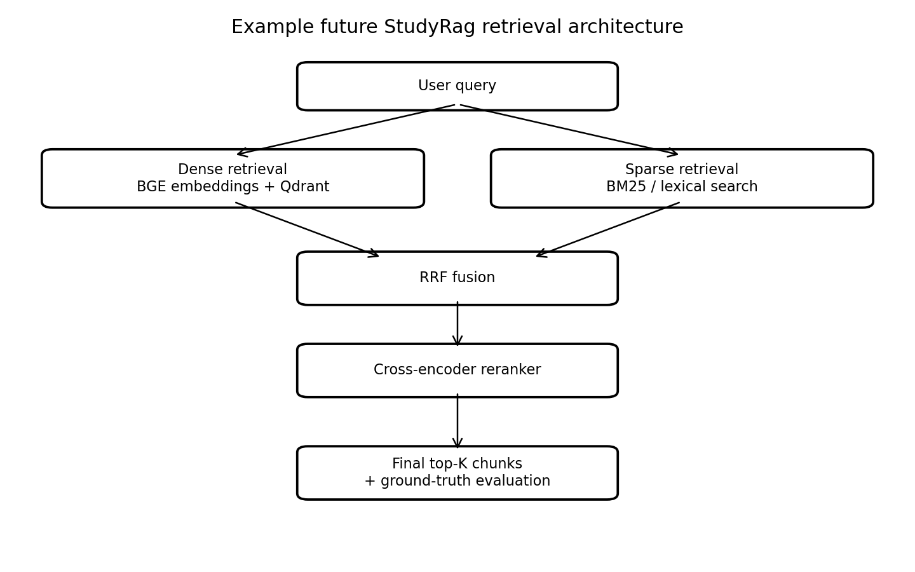
This is a future experiment design, not a claim that these components are already implemented.
Priority | Experiment | Primary metrics to watch
1 | Increase K from 10 to 20 | Hit Rate, Recall, Precision, latency
2 | Add BM25 lexical retrieval | Hit Rate, Recall, Precision
3 | Combine dense and sparse lists using Reciprocal Rank Fusion (RRF) | Recall, MRR, NDCG, MAP
4 | Add a cross-encoder reranker | MRR, NDCG, MAP, latency
5 | Experiment with chunk size, overlap, and chunking strategy | All effectiveness metrics; duplicates
6 | Compare embedding models | Effectiveness metrics, latency, memory

Do not assume increasing K improves everything. It may improve Hit Rate and Recall while lowering Precision@K or worsening ranking metrics if additional results are poorly ordered.

10. Quicklist: the most important metrics for RAG retrieval
Must-have For StudyRag, start with Hit Rate@K, Recall@K, Precision@K, MRR@K, and NDCG@K. Add MAP@K when queries have multiple relevant chunks.

Metric | How to measure | Range | Desired direction | Priority
Hit Rate@K | Queries with ≥1 relevant result / total queries | 0–1 | Higher ↑ | Core
Recall@K | Relevant retrieved / all relevant for query | 0–1 | Higher ↑ | Core
Precision@K | Relevant retrieved / K | 0–1 | Higher ↑ | Core
MRR@K | Mean(1 / first relevant rank) | 0–1 | Higher ↑ | Core
NDCG@K | DCG / IDCG | 0–1 | Higher ↑ | Core
MAP@K | Mean of AP across queries | 0–1 | Higher ↑ | Important
F1@K | Harmonic mean of precision and recall | 0–1 | Higher ↑ | Useful summary
Duplicate Rate@K | Duplicate chunks / retrieved chunks | 0–1 | Lower ↓ | Diagnostic
P95 latency | 95th percentile request time | 0–∞ ms | Lower ↓ | Operations
QPS | Queries / second | 0–∞ | Higher ↑ | Operations

All effectiveness metrics are generally normalized to 0–1, where 1 is best. Latency has no universal numeric target; QPS has no fixed upper bound.

11. Practical score bands: rough starting guidelines
Not universal benchmarks The following bands are rough heuristics for an initial internal benchmark, not industry standards or guarantees. Results depend on K, query difficulty, corpus, annotation completeness, relevance definition, and use case.

Metric | Poor | Moderate | Good | Excellent
Hit Rate | <0.60 | 0.60–0.75 | 0.75–0.90 | >0.90
Recall | <0.50 | 0.50–0.70 | 0.70–0.85 | >0.85
Precision | <0.40 | 0.40–0.60 | 0.60–0.80 | >0.80
MRR | <0.40 | 0.40–0.60 | 0.60–0.80 | >0.80
NDCG | <0.40 | 0.40–0.60 | 0.60–0.80 | >0.80
MAP | <0.40 | 0.40–0.60 | 0.60–0.80 | >0.80
F1 | <0.40 | 0.40–0.60 | 0.60–0.80 | >0.80

For duplicate rate, aim as close to zero as practical without removing useful overlapping evidence. For latency, establish targets based on hardware, corpus/index size, concurrency, and application needs. For QPS, benchmark under realistic load.

12. Worked quick calculation
Assume K = 5, the ground truth contains four relevant chunks, and the retriever returns three relevant chunks. The first relevant result is at rank 2.
Metric | Calculation | Result
Hit Rate@5 | At least one hit | 1.00
Recall@5 | 3 / 4 | 0.75
Precision@5 | 3 / 5 | 0.60
MRR@5 | 1 / 2 | 0.50
F1@5 | 2 × (0.60 × 0.75)/(0.60 + 0.75) | 0.667
NDCG@5 | DCG / IDCG | Depends on relevance grades and positions

MAP also requires the rank positions of every relevant result and is averaged over the query set.

13. Why ranking metrics matter: same recall, different order
Two systems can retrieve the same number of relevant chunks and therefore have identical Hit Rate and Recall, but one can rank the useful chunks much higher.
Rank | System A | System B
1 | Relevant | Not relevant
2 | Relevant | Relevant
3 | Not relevant | Relevant
4 | Relevant | Relevant
5 | Not relevant | Not relevant

If the ground truth contains three relevant chunks, both systems retrieve all three in the top five: Hit@5 = 1 and Recall@5 = 1. However, System A puts a relevant result first while System B does not. MRR, MAP, and NDCG distinguish their ranking quality.

14. Evaluation implementation checklist
- Document the K used for each metric (for example, Hit@10, Precision@10, Recall@10, MRR@10, MAP@10, NDCG@10).
- Verify Recall's denominator is all annotated relevant chunks for that query, not just relevant chunks retrieved.
- Document whether NDCG uses binary or graded relevance and which gain formula is used.
- Calculate metrics per query first, then aggregate. State whether macro averaging is used.
- Define handling of duplicate IDs, duplicate text, overlapping chunks, and multiple relevant chunks.
- Define how queries with no known relevant evidence are handled; do not silently treat undefined recall as zero without documenting the policy.
- Keep the query set and ground truth fixed when comparing dense, BM25, hybrid, and reranked systems.
- Use a per-query report to identify failed questions, low recall, low precision, and ranking problems.
Macro averaging Macro averaging gives each query equal weight. It prevents queries with many relevant chunks from automatically dominating the aggregate score.

15. Suggested evaluation reports

Report A — Retrieval effectiveness
Hit@5, Hit@10; Precision@5, Precision@10; Recall@5, Recall@10, Recall@20; MRR@10; MAP@10; NDCG@10; optionally F1@K and R-Precision.

Report B — Retrieval diagnostics
Failed queries; queries with low recall; queries with low precision; duplicate retrieval rate; unique source/document/section coverage; similarity score distributions; breakdown by query category (numeric_spec, table_lookup, fault_code, procedural, etc.).

Report C — System performance
Embedding latency; Qdrant search latency; result-processing latency; total retrieval latency; P50/P95/P99 latency; QPS; indexing throughput; index size; RAM and disk usage.

16. Retrieval metrics versus answer-generation metrics
Evaluation stage | Examples | Relevant to current StudyRag stage?
Chunk retrieval / IR | Hit Rate, Precision, Recall, MRR, MAP, NDCG | Yes
Retrieval diagnostics | Duplicates, diversity, source coverage, similarity distribution | Yes
System performance | Latency, QPS, indexing throughput, memory, index size | Yes
LLM answer quality | Faithfulness, answer relevancy, answer correctness | No — generation stage later
LLM-judged context quality | LLM-judged contextual precision/recall | Not required for current retrieval-only stage

If the system later retrieves structured answers stored directly in a database rather than document chunks, add answer-level Exact Match and token-level Precision, Recall, and F1 against known answers. Those are answer-retrieval measures and are distinct from document-chunk retrieval.

17. Recommended ground-truth format
For each evaluation question, annotate all known relevant chunk IDs, not just one arbitrarily selected chunk. For example:
{
"id": "q004",
"question": "What minimum megohmmeter reading does Toshiba recommend?",
"relevant_chunks": [
"chunk_123",
"chunk_124"
],
"category": "numeric_spec",
"source": "toshiba_lv_induction_motor_iom"
}
Where possible, also record source document, page/section, evidence text, and relevance grade. Keep chunk IDs stable or maintain a mapping when re-chunking, because chunk IDs may change between pipeline versions.

18. Interview-ready explanations
Question | Concise answer
Hit Rate vs Recall? | Hit Rate checks whether at least one relevant item was found; Recall measures the fraction of all relevant items retrieved.
Why MRR if Recall exists? | Recall ignores rank. MRR rewards finding the first relevant result near the top.
MRR vs NDCG? | MRR considers only the first relevant result; NDCG considers relevance and position across the ranked list.
Why is NDCG normalized? | DCG is divided by ideal DCG, giving a score relative to the best possible ranking.
Which metric should be optimized? | It depends on the use case. Monitor recall for evidence coverage and precision/ranking metrics for relevance and ordering; do not optimize one metric in isolation.

A strong interview summary: Recall measures how much relevant evidence was found; Precision measures how clean the retrieved list is; MRR measures the position of the first relevant result; MAP rewards multiple relevant results near the top; NDCG measures the overall ranking with position discounts and optional graded relevance.

19. Recommended implementation order for StudyRag
- Verify the definitions, cutoffs, and ground truth for the existing Hit Rate, Recall, MRR, and NDCG calculations.
- Add Precision@K and MAP@K. Add F1@K as an optional combined precision–recall measure.
- Measure Recall@1, @3, @5, @10, @20, and @50 to understand the coverage-versus-cutoff trade-off.
- Generate per-query diagnostics containing expected chunk IDs, retrieved IDs, relevance labels by rank, similarity scores, source, category, and failure notes.
- Track duplicate rate and source/section coverage to diagnose chunking and retrieval behaviour.
- Measure embedding latency, Qdrant search latency, total latency, P95/P99, QPS, indexing throughput, index size, and memory.
- Compare dense BGE, BM25, hybrid RRF, and hybrid plus reranking on the same fixed benchmark.
Bottom line Do not change embedding models based only on one aggregate score. First determine whether queries fail because relevant chunks are absent, ranked too low, duplicated, or missing from the ground truth. That diagnosis tells you whether to improve parsing, chunking, lexical retrieval, embeddings, ranking, or evaluation annotations.

